LITERATURE REVIEW



By

Ian Adelman

Devin Hoopes

Natalie Gonzalez

Alex Reinert

Submitted to Dr. Isenberg and Dr. Adams  
of Embry-Riddle Aeronautical University  
in Partial Fulfillment of the Course Requirements for ME 407 and COM 420

9/18/23

1. STATISTICS

Statistics are important to discuss in order to highlight the need for our product. Statistics play a crucial role in product design by providing the evidence needed to make informed decisions, optimize designs, and create products that meet user needs.

* 1. **Cost of Injury**

This study examines workers' compensation claims in Washington State from 1990 to 1998 to assess the prevalence and costs of non-traumatic soft tissue musculoskeletal disorders (NTST-MSDs), including carpal tunnel syndrome and low back disorders. Despite decreases in some NTST-MSD rates, overall rates remained high, impacting industries with heavy manual handling and repetitive work. The study emphasizes the ongoing significance of NTST-MSDs and the need for prevention efforts. [1]

* 1. **Benefits of Powered Hand Trucks**

It is evident from this paper that when comparing powered and unpowered hand trucks and the strain they cause on their operator, the powered versions cause roughly one third of the strain than that of their unpowered counterparts. This insight will help the Atlas system to comply with its major requirement of safety, as being in some way powered will greatly reduce the strain on an operator should there be one. [2]

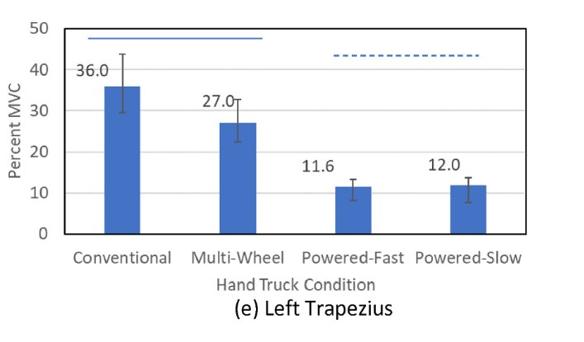

1. STANDARDS

The International Residential Code (IRC) was used for standards and codes as it is an internationally recognized organization which allows for our system to be used not only within the U.S. but potentially globally as well.

* 1. **IRC Section R311**

Section R311 of the IRC contains many restrictions and requirements for staircases and components surrounding the system such as stairway width above and below handrails, as well as required minimum landing depths and more. This is invaluable information as it will provide a solid outline for the Atlas system to work through.[3]

1. PATENTS AND DESIGNS

Research on patents of existing designs show what has worked in the past and what does not. The search was also widened to include any relevant designs that could benefit this product’s final design.

* 1. **Casket Stair Climber**

The Casket stair climber is a system designed to transport caskets up and down stairs, it uses 4 sets of 3-wheels to somewhat roll up a staircase. This system provides useful insight into possible methods of moving objects upstairs, and will be well worth consideration later in the design phase of the Atlas system.[4]

* 1. **Stair-Climbing Apparatus**

The Stair-Climbing Apparatus consists of three rollers which operate in sequence to raise a platform up a given staircase, keeping the platform flat throughout. This design has interesting and useful qualities as compared to other research that will be worth looking into in detail during further comparisons.[5]

* 1. **Portable Stair Lift System**

The portable stair lift system makes use of rails and cabled motors to slide a platform up a given set of stairs. This will make for valuable reference in the further development stages of the Atlas system as the pros and cons of different moving strategies will need to be scrutinized in great detail.[6]

LIST OF REFERENCES

[1] B. Silverstein, E. Viikari-Juntura, and J. Kalat, “Use of a prevention index to identify industries at high risk for work-related musculoskeletal disorders of the neck, back, and upper extremity in Washington state, 1990–1998,” *Am. J. Ind. Med.*, vol. 41, no. 3, pp. 149–169, 2002, doi: 10.1002/ajim.10054.

[2] S. A. Lavender, J. Charbonnet, and C. M. Sommerich, “Biomechanical assessment of alternative hand trucks for transporting heavy loads up and down stairs,” *Appl. Ergon.*, vol. 110, p. 104010, Jul. 2023, doi: 10.1016/j.apergo.2023.104010.

[3] “CHAPTER 3 BUILDING PLANNING, 2021 International Residential Code (IRC) | ICC Digital Codes.” https://codes.iccsafe.org/content/IRC2021P1/chapter-3-building-planning (accessed Sep. 15, 2023).

[4] Palumbo JR., Samuel, “Stair Climber for Casket,” US11691660B2, Jul. 04, 2023 Accessed: Sep. 14, 2023. [Online]. Available: https://patents.google.com/patent/US11691660B2/en?q=(stair+climber)&oq=stair+climber

[5] A. Bouhraoua, N. Merah, J. Al-Muaybid, A. A. Sayoud, A. Al-Darweesh, and J. J. Al-Dawoud, “Stair-climbing apparatus,” US8776917B2, Jul. 15, 2014 Accessed: Sep. 13, 2023. [Online]. Available: https://patents.google.com/patent/US8776917B2/en?oq=us8776917b2

[6] M. B. ME, “Portable Stair Lift System,” PhD Thesis, WORCESTER POLYTECHNIC INSTITUTE, 2021.